Avinash Mulpuru

Cotelligent

Custom Form Development

Multiple Forms

Contents

1 Custom Form Development 2

1.1 System Configuration 2

1.2 Quick Link Category 2

2 Home 3

2.1 Custom Object 3

3 Forms 4

3.1 Create Contractor Form 4

3.2 Capability Selection Form 4

3.3 Application Selection Form 5

4 Identity Cube 5

5 User Rights 6

# 1 Custom Form Development

First Page - Create Contractor with Department Field (department list should be dynamic from custom object, create custom object manually and store list of departments)  
Second Page - Select Admin Role and assign  
Third Page - Select Application (application list be dynamic) and create request .

## 1.1 System Configuration

* **navigate to System Configuration in Debug page open Quick Link Category**

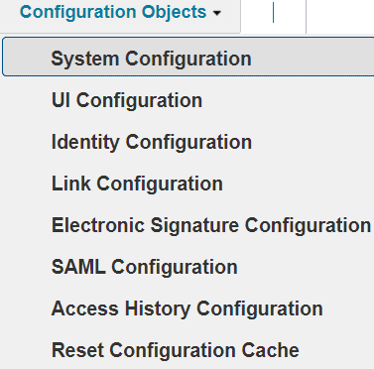

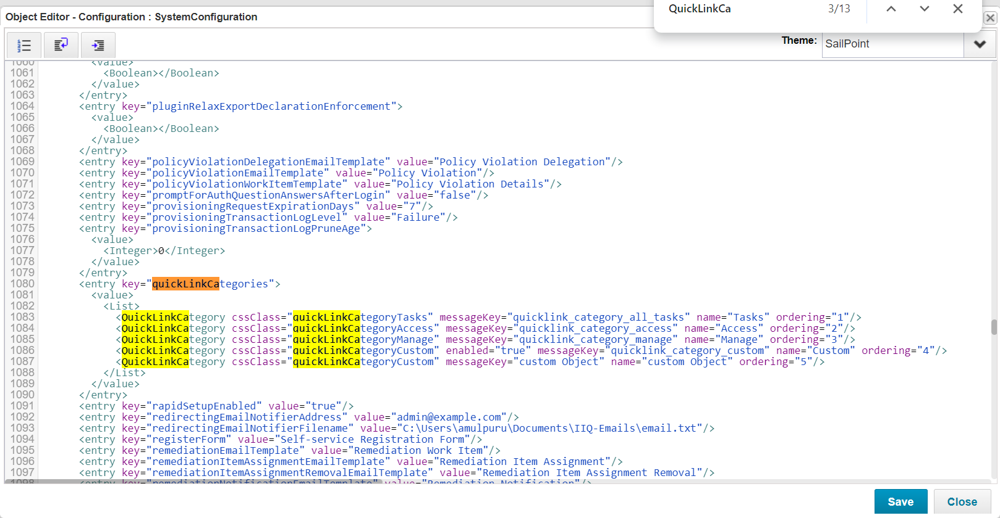



## 1.2 Quick Link Category

* **add the following Quicklink Category**

**<QuickLinkCategory cssClass="quickLinkCategoryCustom" messageKey="custom Object" name="custom Object" ordering="5"/>**

**</List>**

* **Navigate to Quick Link in Debug Page**

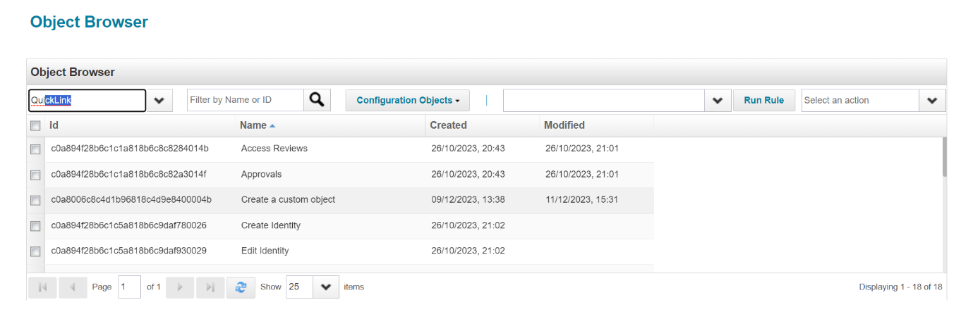

* **Open new add the following Quick Link and save it .**

* **The following Quick Link Consists Of workflow named Create Contractor with Capability.**
* **Navigate to Quick Link Custom Object**

# 2 Home

## 2.1 Custom Object

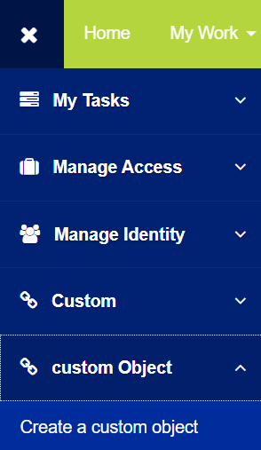

* On Opening Create a Custom Object First Form will Open In which the User Details Are Filled As shown Below

# 3 Forms

## 3.1 Create Contractor Form

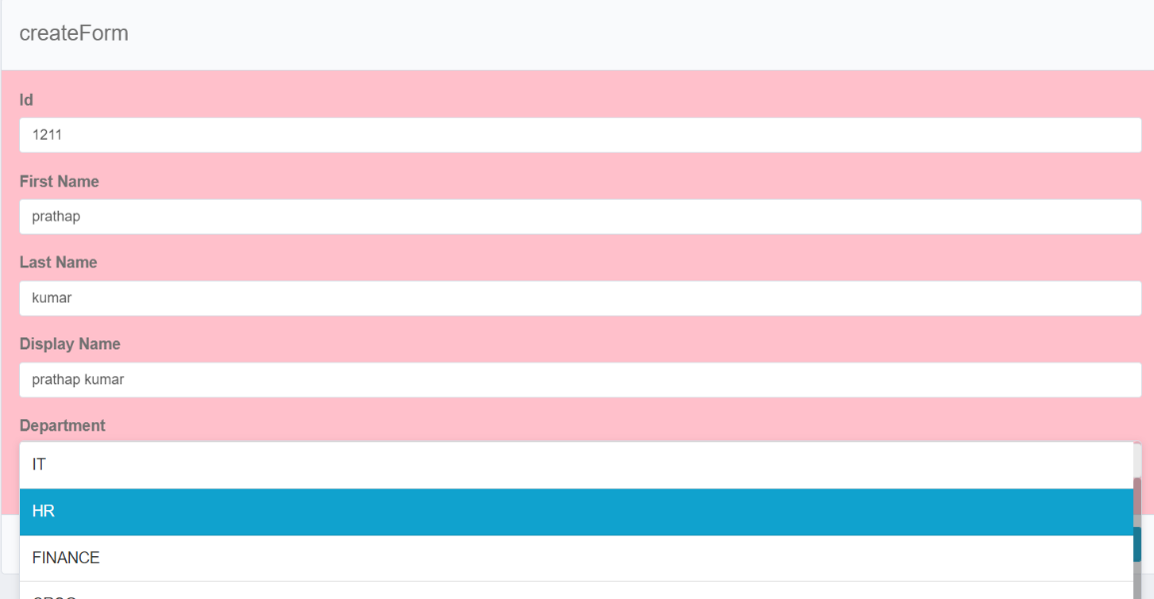

* On Entering Next Button Second Form will Be Opened In which the the Capability needs to be Selected From the Drop Down List of Capabilities as shown below

## 3.2 Capability Selection Form

* On Entering Next Button Third Form Will be Displayed In which the Application needs to be Selected from the Drop Down List of Applications as Shown below.

## 3.3 Application Selection Form

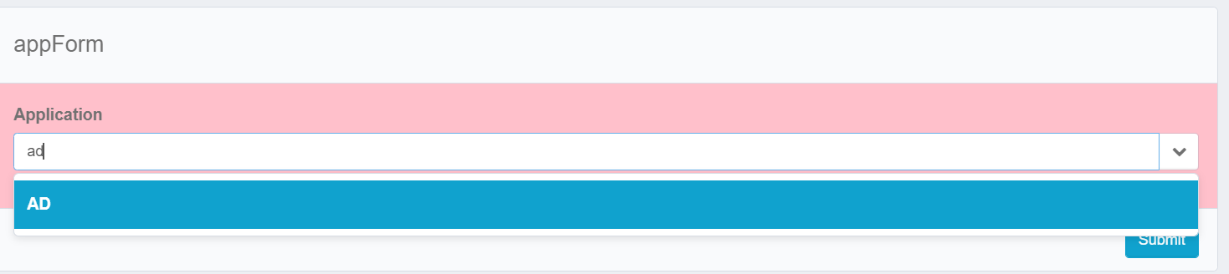

* On Submitting the User(Contractor) will be Created with Selected Capability in Selected Application as show below

# 4 Identity Cube

## 

# 5 User Rights

* 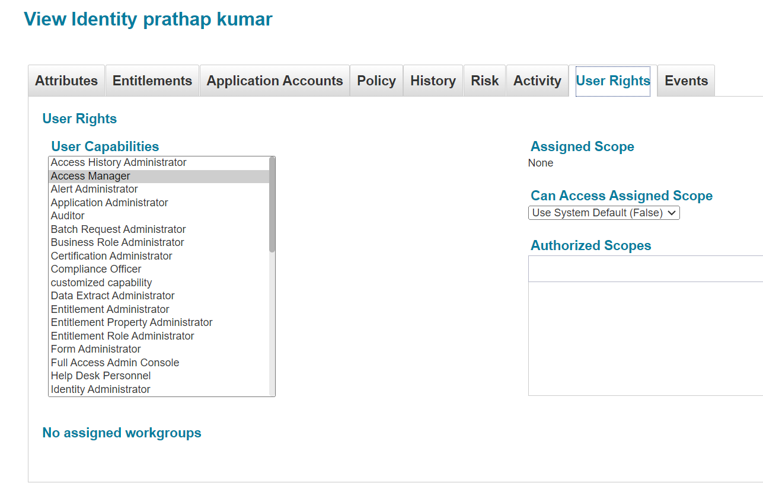The workflow used in the Custom From Development is attached below

